TERM 1 Y8 SCIENCE GUIDLINES FOR MAKING STUDY NOTES
Use your notes to make the study notes, do not go to the internet unless desperate.
LG 1. The Particle model
SC 1 – Explain what a scientific model is and why they are useful. Give an example (hint – see the heading)
SC 2 – List the 5 points of the particle model. Describe solids, liquids and gases by using the words in the particle model to finish the sentences below
A solid ___________________________(2 sentences max)__________________________________
A liquid ___________________________(2 sentences max)_________________________________
A gas ____________________________(2 sentences max)__________________________________
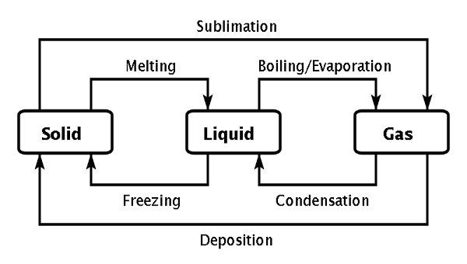
SC 3 – Write definitions for Freezing, Melting, Evaporating, Boiling, and Condensing. Copy the diagram below and use the words above to fill in the blanks.

SC4 – Draw a pictures of the particles look in a solid, and a liquid, and a gas. (ie draw the 3 pictures in the particle model)
LG 2. ELEMENTS, COMPOUNDS, MIXTURES.
SC 6 - Write definitions for element, compound, mixture.
SC 7 – Describe the difference between an element and a compound.
SC 8 – Using circles to show particles draw and label pictures of an element, a compound, and a mixture. The list two examples of a chemical formula for an element and two examples of a chemical formula for a compound.
SC 9 – Copy the table below into your study notebook and fill in the symbols and names of the first 20 elements of the periodic table
1 |  |  |  |  |  |  | 2
3 | 4 | 5 | 6 | 7 | 8 | 9 | 10
11 | 12 | 13 | 14 | 15 | 16 | 17 | 18
19 | 20
SC 10 – List the metals in the first twenty elements.
LG 3. Physical and Chemical CHANGE
SC 11 – write definitions for Physical change, and Chemical change.
SC 12 – Under a heading “Four signs that a chemical change has occurred”, list the four observable signs that a chemical change has occurred
SC 14 – Why are chemically reactive substances (substances which react quickly) not very useful for construction or jewellery?
SC 15 – Copper metal is usually used for electrical wiring. List the properties of copper which make it useful for this purpose, and explain why these properties are useful for the job of conducting electricity in wires.

